PRESS RELEASE:

SERIALITY
A Group Exhibition

December 4, 2021 – January 8, 2022

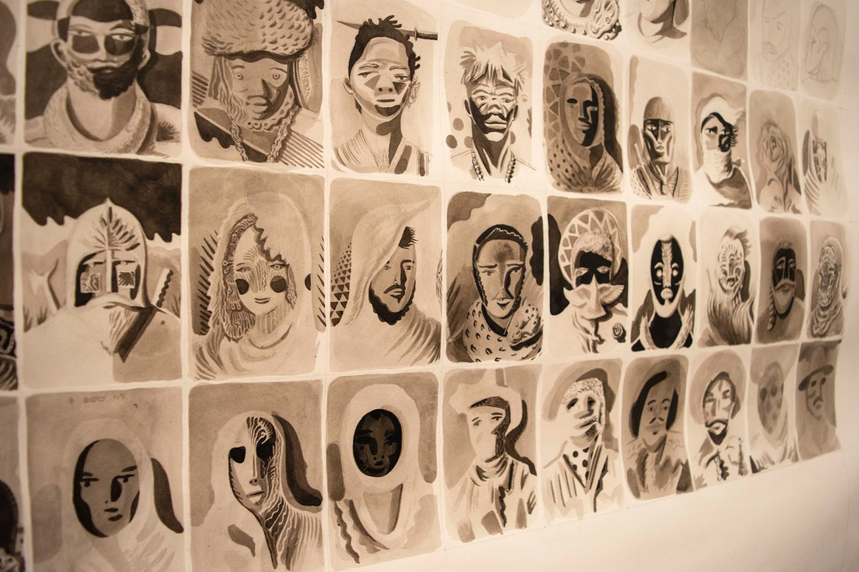
LAWRENCE LEE
Untitled, 2021
India ink and pencil on paper
60 x 60 inches
Detail image

Barry Whistler Gallery is pleased to present SERIALITY: A Group Exhibition.

The exhibition runs December 4, 2021 – January 8, 2022. There will be an open house December 4, 2021 from 12 - 3PM.

Included in the exhibition are artists: Ed and Linda Blackburn, Linnea Glatt, Sam Gummelt, Lawrence Lee, Peter Ligon, John Pomara, Andrea Rosenberg, Lorraine Tady, John Wilcox, and Mark Williams.

The show (its title formally defined as, “A serial quality or state”) will focus on works that offer a sense of repetition and oftentimes progression. The successive and sequential works then work to build a narrative.

Lawrence Lee discusses his narrative that unfolds in his 60” square drawing, “I am writing a story that takes place in another world and the drawing depicts some of the warriors that live there. In the story there is a mountain island in the middle of the ocean where a certain bird lives. Once every 700 years, the bird begins to sing and the song can be heard all over the world. Warriors from all corners of the world can hear the singing and the bravest among them respond. They sail to the mountain and attempt to ascend its side. The mountainside is filled with peril, dangerous beasts, and poisonous plants. The first seven warriors to reach the top and pluck one of the bird’s tail feathers become immortal warriors/protectors of the world. They serve to protect inhabitants of the world until the bird sings again after many years. The drawing depicts these brave heroes as they first behold the isle on the horizon.”

Artist Mark Williams explains his choice of material, “During the pandemic, groceries and household needs are delivered in cardboard boxes. Normally, I paint on stretched canvas or wood panels. That changed in April 2020. I began to paint on cardboard cut from the delivery boxes. The cardboard is readily available and offers a more relaxed open way of working. It has a color quality and visual texture that I find appealing, and using

the cardboard compels me to make different decisions about structure and applying paint. The raw/exposed cardboard is an important visual element in a finished work. I use oil paint, shellac, and pencils. I begin each work by cutting a piece of cardboard to a rectangular shape. I add a second layer of cardboard. Now I have something I want to paint on. I respond to this construction using self-imposed rules for creating an artwork (abstract, geometrical, rectilinear, asymmetry , 2-4 colors, pencils lines). My rules are restrictive, but I reserve the option to change them. My goal for each painting is to create a cogent image that adheres to my intuitive sense of “rightness”.

Additional information and images available upon request.

