PRESS RELEASE:

ANN STAUTBERG
Times Change

November 13, 2021 – January 8, 2022

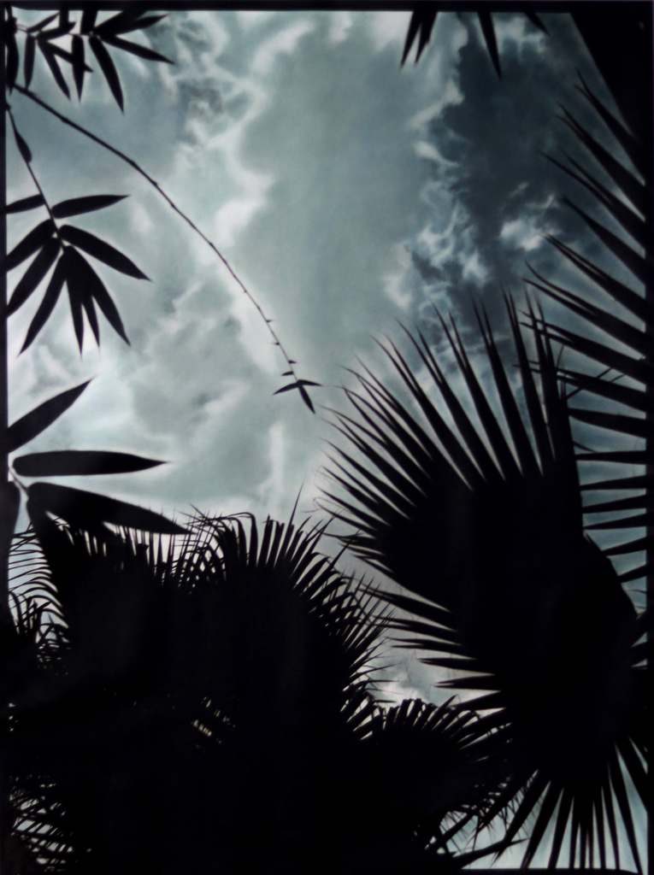

ANN STAUTBERG
11-20-20, 2021
Oil on archival printed canvas
85 x 64 ¾ inches
Edition 1/3

Barry Whistler Gallery is pleased to present Ann Stautberg’s newest body of work, Times Change.

The exhibition runs November 13, 2021 – January 8, 2022. There will be an open house November 13, 2021 from 12-3PM.

Stautberg currently lives and works in Houston where she survived the pandemic but says that winter storm Uri in 2021 gave her a new awareness of our relationship to nature and changing times.

She continues photographing the sky, but silhouetted botanical shapes have started appearing more predominately in her work. Visually present is the use of drama, psychological tension, and the mood of the times. Stautberg’s garden, an ongoing source of inspiration, is full of Mexican fan palms that were dramatically changed after storm Uri resulting in her printing and working on images that no longer existed during the pandemic.

Although her work doesn’t appear “documentary”, Ann Stautberg has always utilized that approach with her photography. Since her undergraduate days, she has worked with large scale pieces. Stautberg says she has always enjoyed the presence that scale allows.

Eleven pieces will be featured in the show. Each photograph is first printed with archival inks onto stretched canvas. The artist then tints the pieces with photographic oils by hand—a technique which she uses in addition to digital processes.

Stautberg works from her home saying it gives her a “sense of place”. Barry Whistler Gallery has represented her since 1986.

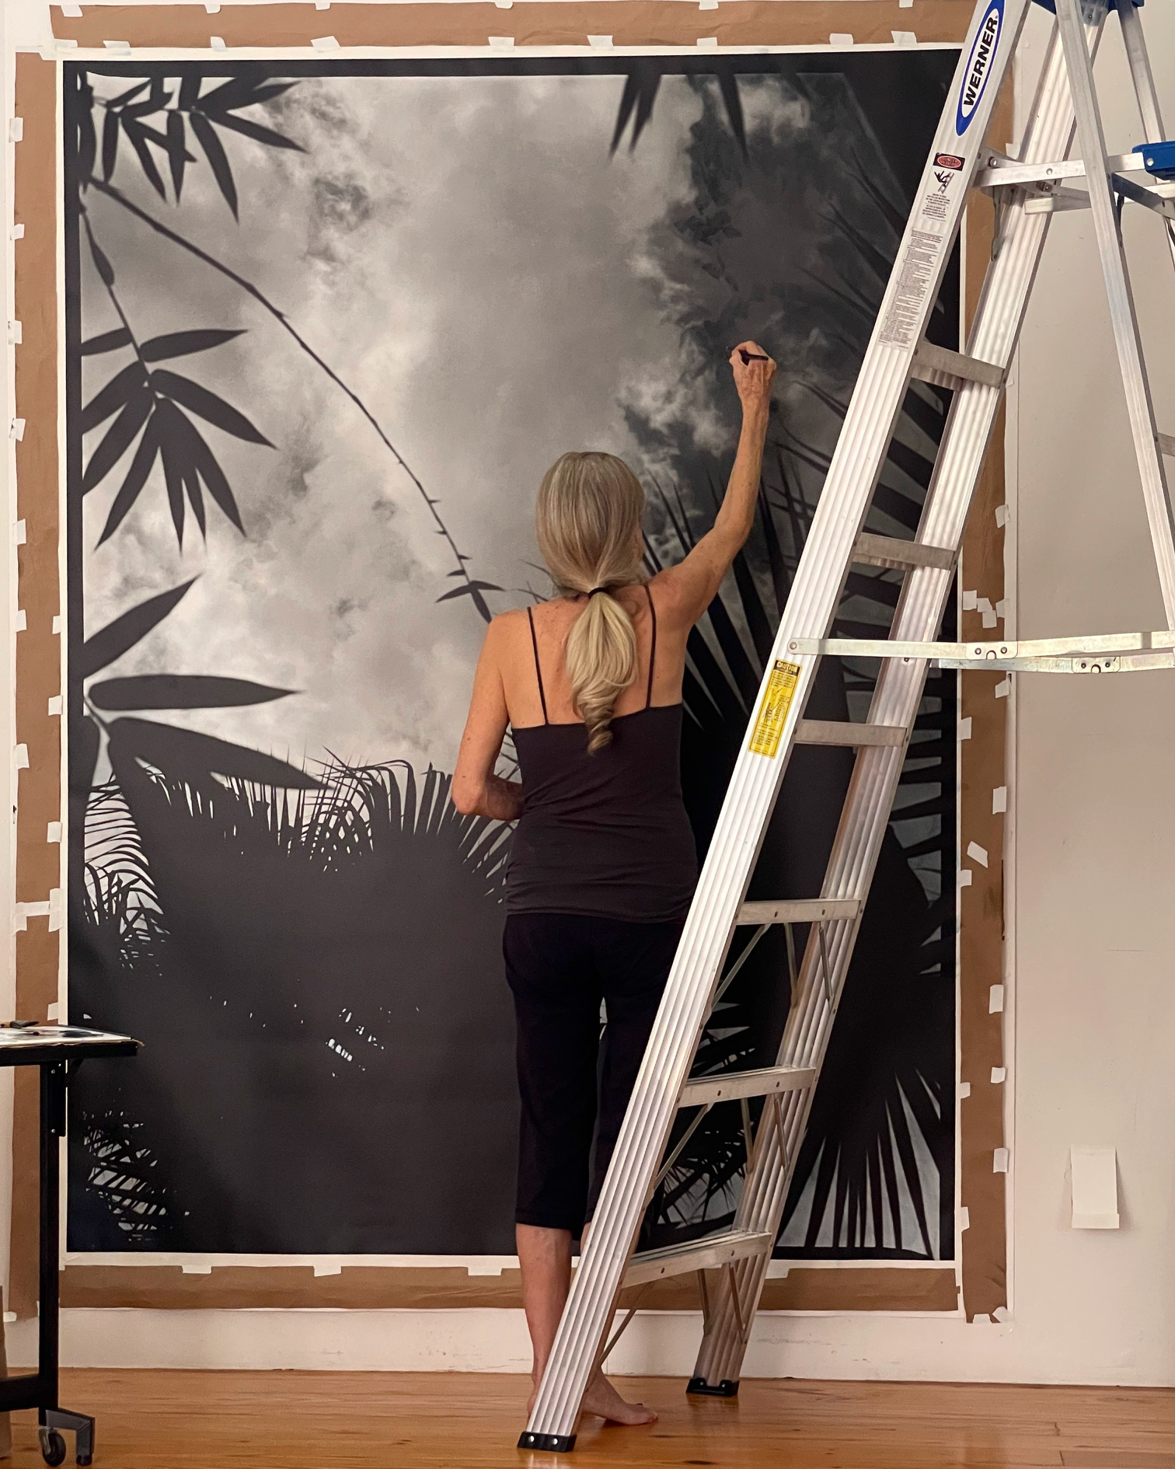

Artist Ann Stautberg working in her Houston studio.
Photograph courtesy of Frank X Tolbert

Additional information and images available upon request.

