PRESS RELEASE:
TOM ORR
NEW WORKS ON PAPER
&
FRANCES BAGLEY
THE ESCAPE
October 19 – November 23, 2019

Tom Orr
Waterfall #2, 2019
Archival inks on paper
96 x 40 inches, Edition 1/3

Barry Whistler Gallery is pleased to present the work of Tom Orr and Frances Bagley. The opening reception for the exhibition New Works on Paper & The Escape will take place on Saturday, October 19th from 6-8pm.

Tom Orr is an interdisciplinary artist born here in Dallas, Texas. He has exhibited extensively during his career both in the United States and in Japan.

His site-specific works have been installed in places ranging from John Michael Kohler Art Center in Sheboygan, Wisconsin, to the 21st Exhibition of Contemporary Sculpture in Ube Japan.

New Works on Paper explores illusions of falling water. Orr states, “My drawings, printed on vertical black lines, are meant to create the sense of falling water in the form of waterfalls.”

Works included in the show are large scale, one work spanning over twelve feet. Orr’s show explores depth and optics executed by overlapping black lines and Orr’s drawings. The drawings create aberration’s for the viewers, challenging the mind to focus on the pieces in a “big picture” way.

In 2011 Orr was awarded a Pollack Krasner Foundation Grant. Most recently, Tom Orr and Frances Bagley—married in 1988—completed their twelfth collaborative commission; a monumental work using lights and sculpture on the campus of the University of Texas Southwestern Medical School.

The many collections in which Tom Orr is represented include the Foundation of Culture in Osaka, Japan; The El Paso Museum in Texas; and the Utsukushi-Ga-Hara Open-Air Museum in Nagano, Japan. Among his public art projects are two large-scale wall installations in the international terminal at the Dallas Ft. Worth Airport. An even larger scale sculpture graces the main terminal entrance to Dallas Love Field Airport.

In 2005 Orr and Bagley designed the sets and costumes for the Dallas Opera’s production of Verdi’s Nabucco, which celebrated the Opera’s 50th anniversary season. The project was followed by an invitation from the Dallas Museum of Art to create a museum installation based on the set designs from the opera for the exhibition Performance Art.

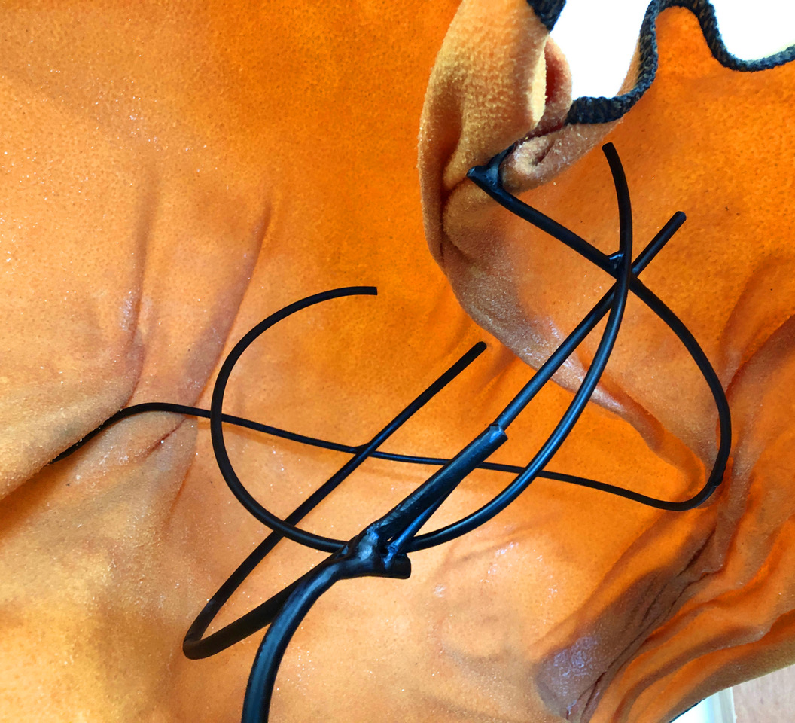

Frances Bagley
Detail: The Escape

Born in Fayetteville, Tennessee, Frances Bagley earned her MFA in Sculpture from the University of North Texas after receiving her MA and BFA in Painting from Arizona State University. She currently lives and works in Dallas, Texas.

Throughout her 40-year career, Bagley has exhibited extensively along with a strong community involvement in support of women’s rights and artist’s rights. She has been a member of the women’s collaborative, Toxic Shock since it’s beginning in 1980.

Bagley explains, “My work is informed by situations of social concern and often asks questions about the human experience in relation to the environment, architecture, and society.”

An award recipient in the 10th Kajima Sculpture Exhibition in Tokyo, Japan, and in the 2007 Texas Biennial, Bagley’s work is included in museum and corporate collections, including The Dallas Museum of Art; The National Museum of Women in Washington D.C.; The El Paso Museum; and American Airlines, among others.

In regards to her work featured here Bagley states, “The Escape implies an open-ended narrative for the viewers to complete in each of their imaginations.”

Additional information and images available upon request.

